1. **Analysis 3**

1) The memory usage of the data is around 6.1 mb.How can we reduce the memory usage of the data set?  
 2) What is the Average price of vehicle by fuel type and gearbox type.Give a plot

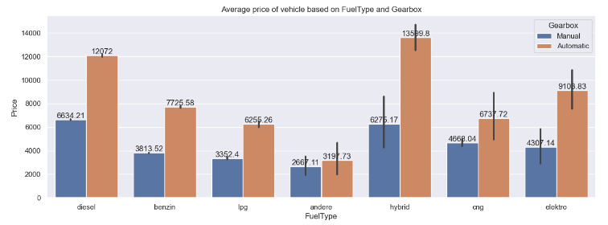

* The highest average price is for the fuel type “hybrid” having “automatic” gearbox
* Among “manual” gear box,the highest average price is for the vehicle having fuel type “diesel”.
* The least price is for the vehicle having fuel type “andere” for both “manual” and “automatic” gearbox.

3) What is the Average power of a vehicle by vehicle type and gearbox type.Give a plot

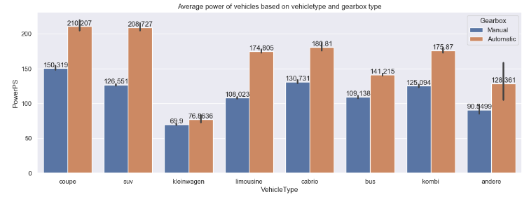

* “Coupe” vehicle type with both “Automatic” and “Manual” gearbox type is having high power followed by “suv” , “kombi”
* “Automatic” gearbox type is having high power when compared to “Manual”.

4) What is the Average price of a vehicle by brand as well as vehicle type.Use heatmap to explain this

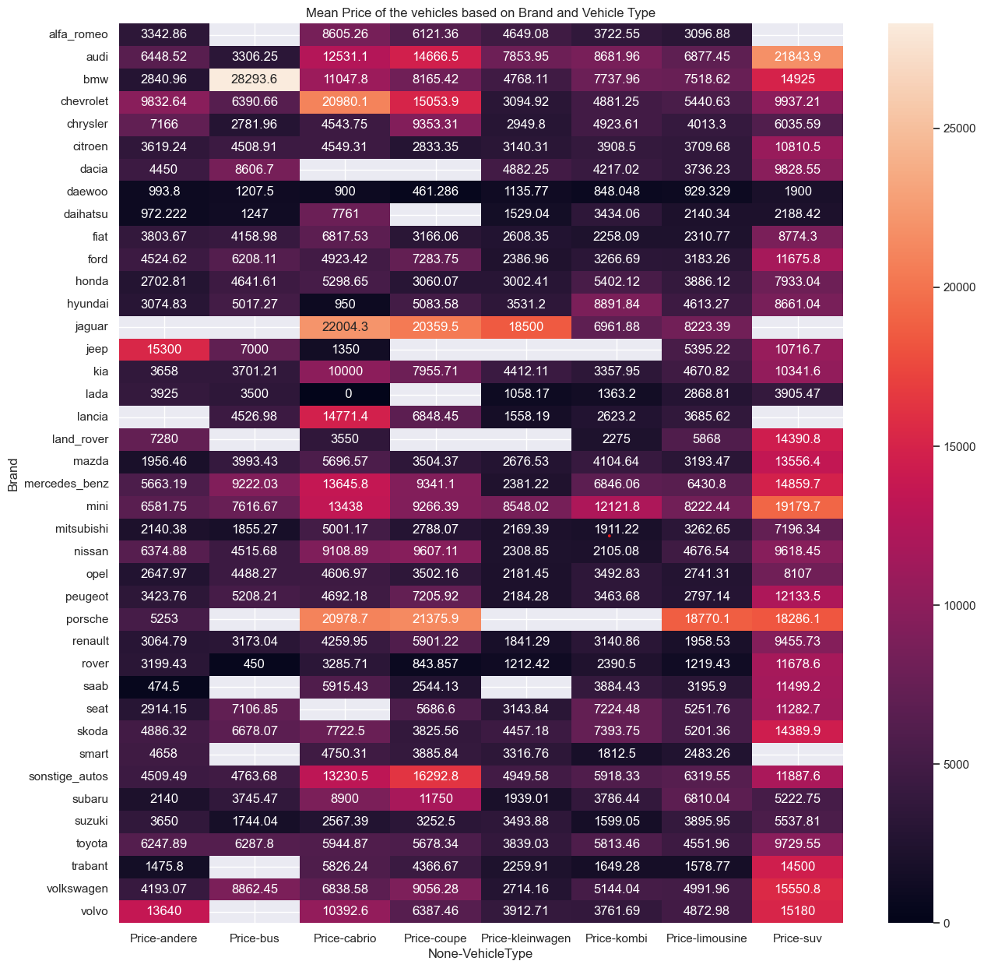

* The highest average price is for the vehicle “jaguar-cabrio” and second place is occupied by “audi-suv”.
* The least average price is for “daewoo-cabrio” and second least is “daewoo-andere”
* “kleigwagen” average price is between $1000 and $5000